Ashley, Bruce
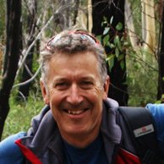
Bruce's background is as a qualified environmental scientist and recreation planner, having studied BSc (Forestry) at the Australian National University, Canberra 1975-79, and Recreation Planning at Canberra University. From 1981-84: OIC of Forests Department Inventory & Planning Office in Northern Region and Forests Officer in Collie District. Environmental & Cycling Consultant with The Environment Works Pty Ltd 2000 – Present (13 years) Sydney NSW. He has had over 20 years experience as a freelance environmental and bicycle planning consultant.

